A11 - Ethical and Environmental Analysis

Year: 2024 Semester: Spring Team: 2 Project: MOUSE

Creation Date: April 1, 2024 Last Modified: April 5, 2024

Author: Christopher Miotto Email: cmiotto@purdue.edu

1. Environmental Impact Analysis

MOUSE has many different components. The main components include metal chassis wheels and motors, 3D printed packaging, li-po battery, and a PCB. On this PCB we have many soldered components. For each of these main components there are 3 stages of environmental impact that we must analyze: manufacturing, normal use, and disposal.

First, we will analyze the environmental impact of the PCB at these 3 stages. The manufacturing of the PCB can have a large impact on the environment. During PCB manufacturing the etching process is done to remove excess copper. This process is done by using toxic chemicals. These toxic chemicals mix with the removed copper to create a wastewater treatment sludge [1]. During an analysis of a PCB plant in Turkey, it was found that this sludge contributes freshwater aquatic ecotoxicity potential, which is the toxic effect of chemicals on an ecosystem, and ozone layer depletion [1]. This environmental impact can be reduced by limiting the overall footprint of the PCB. By making a smaller PCB the amount of chemicals needed to etch will be reduced, thus reducing the environmental impact. During normal use, the PCB has no environmental risk, but during disposal there are possible risks. During disposal of the PCB, we must take precautions to recycle the PCB instead of throwing it out. If a PCB is thrown out it may leak toxic chemicals into its surrounding ecosystem. However, if a PCB is recycled, we can achieve a 95% separating ratio, which allows for the metals and nonmetals to be reused, decreasing the environmental impact [2]. Thus, we can reduce this environmental impact by recycling the PCB after use.

Second, we will analyze the environmental impact of the metal chassis wheels and motors at the 3 stages of environmental impact. During the manufacturing all of these components use metal, thus subtractive manufacturing to create these components is used. Subtractive manufacturing is when we remove material to manufacture a part. This removal of material leads to waste which can have an environmental impact. This waste can be reduced by using fewer complex geometries and more commonly available parts. By using commonly created parts, we can reduce the amount of waste due to companies producing at economies of scale, which will reduce manufacturing costs and in turn reduce waste. During normal use these components have no risk to the environment. During disposal there is a possible risk to the environment. With these components being mainly metal, by throwing the components out we risk impacting ecosystems. Instead, by recycling metal we can reduce this possible impact. All metals can be recycled, aluminum and steel which is most likely the metals within our components are both recyclable [3]. Recycling aluminum uses 95% less energy than when it is produced using raw material [3]. Also, around 40% of all aluminum and steel is currently metal from recycled sources [4].

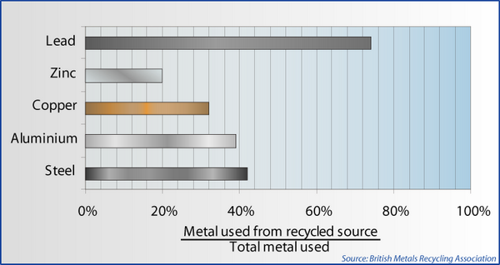

Figure 1: Metal used from recycled source / Total metal used [4]

By proper disposal, we can even reduce the environmental impact of manufacturing. Thus, by recycling we can limit the impact of these components on the environment.

Third, we will analyze the environmental impact of li-po batteries at the 3 stages of environmental impact. During manufacturing there are many possible environmental concerns. Production requires the mining of many different materials, like lithium, cobalt, and nickel [5]. The mining of these materials has a high environmental cost, by producing toxic fumes and contaminating nearby water. During normal use a li-po battery has no environmental impact. During disposal there is a large environmental impact. Due to the use of toxic chemicals, li-po batteries are considered hazardous materials. If not properly disposed of the battery can end up in a landfill, and release toxins contaminating local water supplies [6]. Also, within a landfill a battery can spontaneously combust, starting a fire. It was reported that 124 fires were started due to li-po batteries in just one landfill from 2017-2020 [6]. By using only, a single battery to operate MOUSE we can reduce the environmental impact of production. Also, by properly disposing of the li-po we can reduce the environmental impact of disposal.

Finally, we will analyze the environmental impact of the 3D printed packaging at the 3 stages of environmental impact. During manufacturing there are a few risks to the environment. The main risk being the usage of supports during 3D printing can lead to a large amount of waste. Any angles with a overhang above 60 degrees will need support from plastic. This support plastic is not used in the final product and instead thrown away. However, this support plastic can be recycled. By shredding the waste material into small pieces then melting and re extruding you can create new filament for 3D printing [7]. During normal use the 3D printed packaging has no risk to the environment. During disposal the same concept as manufacturing can be followed. By recycling the 3D printed packaging, we can reduce the possible environmental impact of waste. Overall, by recycling 3D printed material we can reduce the environmental impact at the manufacturing and disposal stages.

1. Ethical Challenges

Due to MOUSE being a software controlled mobile unit, potential ethical challenges can occur. These ethical challenges include failure of software, mobile collisions, rotating motor related injuries, and battery related dangers.

The first possible challenge is with failure of software. Due to MOUSE being controlled via Wi-Fi, there are no on-board physical controls. If the Wi-Fi connection were to be disconnected during movement communication, there is a possibility of movement becoming erratic. With our current iteration we do not have a software solution to this problem. This is because all communication is done via Wi-Fi so if communication is stopped, we will not be able to control MOUSE’s movement. In future iterations we would like to include a software solution. However, there is currently a physical power switch on the body of MOUSE, thus if communication is disrupted, the power to MOUSE can be physically cut by turning off the power.

The next challenge is similar to the result of software failure, which is the possibility of mobile collusions. Due to MOUSE being controlled manually, if the driver were to have malicious intent, they could drive MOUSE into a bystander. With this in mind, our current iteration is capped to a max speed of around 5 feet per second. At this max speed and the somewhat light weight and size of MOUSE the possible damage to a bystander should be minimal. Also, as mentioned previously, there is a manual power switch which can be used if a collision cannot be avoided.

The third challenge is the possibility of rotating motor related injuries. If MOUSE were to collide with a bystander, the usage of rotating parts could be dangerous to the bystander. MOUSE currently uses 4 rotating motors for movement, and one rotating stepper motor for sensor operation. At the max speed of 5 feet per second the number of rotations is relatively high, if clothing or body parts get stuck within these rotating parts there may be injuries. To combat this, our current motors use a low amount of torque which limits the amount of danger to a bystander. Also, as mentioned before, the usage of the external power switch may be used to avoid further harm.

The final challenge is battery related danger. Currently MOUSE utilizes a li-po battery to power itself. This li-po battery is a 18.5V five cell battery. As previously mentioned, li-po batteries contain toxic materials, which if used improperly can be exposed. Mishandling of these batteries can lead to fire explosion and toxic smoke inhalation [8]. To minimize these dangers the li-po battery is currently contained with a li-po safe bag, which will contain a battery explosion if it were to occur. This li-po safe bag also has a large warning symbol on it which informs the user of its possible danger.

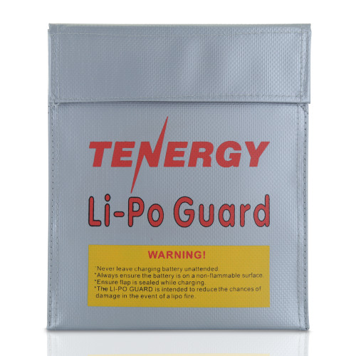



Figure 2: Li-Po Safe Bag with Warning Label

3.0 Sources Cited

[1] E. Ozkan, N. Elginöz, and F. G. Babuna, “Life cycle assessment of a printed circuit board manufacturing plant in Turkey,” *Environmental Science and Pollution Research International*, vol. 25, no. 27, pp. 26801–26808, Sep. 2017, doi: 10.1007/s11356-017-0280-z.

[2] D. Xiang, M. Peng, J. Wang, G. Duan, and H. Zhang, “Printed circuit board recycling process and its environmental impact assessment,” *International Journal, Advanced Manufacturing Technology*, vol. 34, no. 9–10, pp. 1030–1036, Oct. 2006, doi: 10.1007/s00170-006-0656-6.

[3] A. M. Recycling, “The world of Metal Recycling: The Facts,” *ASM Metal Recycling*, Jun. 18, 2018. <https://www.asm-recycling.co.uk/blog/the-world-of-metal-recycling-the-facts/#:~:text=Steel,as%20'tinned'%20cans>).

[4] Department of Materials Science and Metallurgy - University of Cambridge, “What metals can be recycled?,” *Creative Commons Attribution - NonCommercial-ShareAlike 4.0 International*. https://www.doitpoms.ac.uk/tlplib/recycling-metals/what.php

[5] L. R. B, “The environmental impact of battery production for EVs,” *Earth.Org*, Mar. 04, 2024. <https://earth.org/environmental-impact-of-battery-production/>

[6] Ier, “Environmental Impacts of Lithium-Ion Batteries - IER,” *IER*, May 11, 2023. <https://www.instituteforenergyresearch.org/renewable/environmental-impacts-of-lithium-ion-batteries/>

[7] M. Jones, “PETG/PLA recycling: How to recycle 3D printer waste,” *All3DP*, Nov. 30, 2023. <https://all3dp.com/2/3d-printer-recycled-plastic-tips-for-your-waste-plastic/>

[8] “LIPO Safety & Warnings.” <https://power.tenergy.com/lipo-safety-warnings/>